A Project Report on
Fraud Pulse
AI Driven Fraud Intelligence Platform
By
Mr Jagdish Dilip Chavan (20250202022)
MCA – I, SEM – I
2025-26
To
Savitribai Phule Pune University, Pune

In Partial Fulfilment of the Degree of
Master in Computer Application (M. C. A.)

Under The Guidance Of
Prof. Megha Mane

Suryadatta Group of Institute, Pune

Suryadatta Institute of Business Management and Technology (SIBMT)

CERTIFICATE

This is to certify that Mr Jagdish Dilip Chavan, has successfully completed his/her project work entitled “Fraud Pulse-AI Driven Fraud Intelligence Platform” in partial fulfilment of MCA – I for the year A.Y. 2025-26. They have worked under our guidance and direction.

Prof. Megha Mane Dr. Manisha Kumbhar
(Project Guide) HoD-MCA, SGI

Examiner 1 Examiner 2

Date:
Place:

Acknowledgment

We are the student of MCA first year. Here by I express our thanks to our project guide for allowing us to do the project on Fraud Pulse AI Driven Fraud Intelligence Platform This project work has been the most exciting part of our learning experience which would be an asset for our future carrier. I would especially like to thank our guide and mentor Prof. Megha Mane, who constantly guided us in developing, pushing us to search for more answers to her numerous questions. Also, I would like to thank Prof. Megha Mane, project coordinators for her support. As a building block of MCA Department, I thank Dr. Manisha Kumbhar, HOD, MCA Department for her continuous support and help. We are grateful to many classmates who contributed their suggestions. Their hard work and examples push us to limits of our capability and encourage us daily.

Thank You

Student Name:
Mr. Jagdish Dilip Chavan

Index
Chapter | Page number
CHAPTER 1: INTRODUCTION
1.1 Existing System | 8
1.2 Need for System | 10
1.3 Operating Environment Hardware and Software | 11
1.4 Brief Description about Technology Used | 13
CHAPTER 2: PROPOSED SYSTEM
2.1 Proposed System (Introduction of system) | 16
2.2 Module specifications (Scope) | 18
2.3 Objectives of System | 21
CHAPTER 3: ANALYSIS & DESIGN
3.1 ERD Diagram | 24
3.2 Use Case Diagrams | 26
3.3 Activity Diagram | 34
3.4 Sequence Diagram | 40
3.5 Class Diagram | 42
3.6 Module Hierarchy Diagram | 43
3.7 Table specifications (Database design) | 45
3.8 Data dictionary | 47
CHAPTER 4: USER MANUAL
4.1 User Interface Screens (Input) | 50
4.2 Output Screens with data | 52
4.3 Data Reports | 56
4.4 Sample program code | 59
4.5 Limitations | 67
4.6 Test Case | 69
Bibliography | 72

CHAPTER: 1. Introduction

1: INTRODUCTION:
The global financial services landscape is undergoing a profound transformation, driven by the rapid digitization of banking channels and the exponential growth of real-time payments. While this digital evolution has enhanced customer convenience and transaction velocity, it has simultaneously introduced complex security challenges. Financial fraud has evolved from simple, isolated incidents into a sophisticated, organized criminal enterprise that leverages speed and automation to exploit vulnerabilities in banking ecosystems. For modern financial institutions, the ability to secure customer assets is no longer just a compliance requirement; it is a fundamental pillar of brand trust and operational resilience.
In this high-stakes environment, the traditional approach to fraud management often characterized by reactive investigations and static rule-based monitoring is proving increasingly inadequate. As transaction volumes surge, the reliance on manual verification processes creates significant operational bottlenecks. This lag in detection not only exposes the bank to direct financial liability but also creates friction for legitimate customers who often face delays or erroneous account freezes due to imprecise detection methods. The industry is facing a critical need to pivot from "detect and recover" strategies to "predict and prevent" methodologies.
FraudPulse: AI-Driven Fraud Intelligence Platform is conceived as a strategic response to these challenges. It is a specialized, real-time decision support system designed to integrate seamlessly into the bank's existing infrastructure. Unlike legacy systems that rely on predetermined thresholds, FraudPulse harnesses the power of advanced Machine Learning (ML) to analyze vast datasets of historical transaction behavior. By identifying subtle, non-linear patterns such as abnormal spending velocity, irregular balance shifts, and complex behavioral anomalies the system provides a depth of risk insight that is impossible to achieve through human auditing alone.
The core philosophy of the FraudPulse project is to empower the financial institution with "Intelligence at the Speed of Transaction." The platform serves as a critical defense layer, intercepting high-risk transactions and providing Risk Analysts with an immediate, data-backed probability score. This capability transforms the role of the fraud department from a retrospective investigative unit into a proactive risk containment force. By reducing the time-to-decision from hours to milliseconds, FraudPulse not only minimizes financial losses associated with fraud (False Negatives) but also significantly lowers the operational costs involved in investigating false alarms (False Positives).
Ultimately, this project represents a convergence of modern MLOps architecture and banking compliance standards. It aims to deliver a robust, scalable, and auditable solution that safeguards the bank’s capital while ensuring a frictionless and secure experience for the end customer.

  - Existing System:
The existing fraud detection infrastructure in the banking sector typically relies on legacy rule-based engines. As identified by Kumar and Singh (2024), these systems utilize static, deterministic logic that often results in high false positive rates, necessitating the optimization of detection methods through ensemble techniques [1].
In this traditional framework, detection is constrained by linear thresholds (e.g., specific transaction amounts or velocity limits). Shi (2025) highlights that such linear methods are insufficient for capturing the complex, non-linear behavioral patterns inherent in modern credit card fraud, which sophisticated algorithms like XGBoost are designed to uncover [2]. Furthermore, the operational workflow often lacks seamless integration with real-time decisioning tools. Herianto (2025) notes that bridging this gap requires robust application frameworks (such as Python-based web apps) to effectively deploy machine learning models into practical production environments [3].
Comparing these legacy systems to modern architectures, Al-Surkhi and Maqableh (2024) emphasize that traditional methods fall short in performance when opposed to advanced Ensemble and Deep Learning methodologies, particularly in processing online transaction streams [4]. Consequently, as the volume of digital transactions grows, Sarna et al. (2023) conclude that financial institutions must transition toward automated machine learning solutions to handle the increasing scale and complexity of fraud in the financial domain [5].
A critical failing of current systems is their inability to handle the severe skew in transaction data. Al-Surkhi et al. (2025) demonstrate that legacy systems fail to address "Class Imbalance," whereas modern Stacking Ensembles (using techniques like K-SMOTEENN) significantly improve the detection of rare fraud events [6]. Moreover, Mohammed and El Kafhali (2024) argue that standard single-model systems lack the predictive stability of Stacking frameworks, which utilize meta-learners (like Logistic Regression) to aggregate disparate risk signals effectively [7].
The industry is therefore witnessing a definitive shift away from static rules. Alessi and Fugini (2024) report a growing adoption of Boosting techniques to replace manual verification, citing their superior ability to reduce operational costs [8]. Finally, the most pressing limitation of the existing infrastructure is latency. Borketey (2024) asserts that "Real-Time" detection is no longer optional but mandatory, as legacy batch-processing systems cannot intercept fraud before settlement, leading to unrecoverable financial losses [9].

1.2 Need for System:
The rapidly evolving landscape of global finance has created an urgent imperative for advanced fraud intelligence platforms. As digital transaction volumes surge, the "attack surface" for financial crime has expanded, rendering traditional defense mechanisms obsolete. The need for a system like FraudPulse is driven by critical market trends and operational necessities identified in recent industry reports.
1. The Strategic Necessity of AI Adoption The financial sector is currently undergoing a massive shift towards automation. According to the AI in Banking Market Report (2025), the integration of Artificial Intelligence is no longer a luxury but a fundamental requirement for maintaining competitive advantage and security. Financial institutions need systems that go beyond static rules to leverage the predictive power of AI, enabling them to anticipate threats rather than merely reacting to them.
2. Escalating Financial Liability The cost of fraud is rising exponentially. Precedence Research (2025) forecasts that the AI in Fraud Management market will surpass USD 65.35 Billion by 2034, driven largely by the desperate need to mitigate the colossal financial losses associated with digital payment fraud. Banks require a high-recall system capable of intercepting these losses pre-settlement to protect their bottom line.
3. Complexity of Modern Fraud Vectors Fraudsters are increasingly using AI themselves to conduct sophisticated attacks. Dimension Market Research (2025) highlights that the market for AI in fraud detection is expanding specifically to counter these complex, non-linear threats that legacy systems fail to catch. There is a critical need for an adaptive solution (like our Stacking Ensemble model) that can identify subtle behavioral anomalies—such as "low-and-slow" attacks—that evade simple threshold checks.
4. Combating the Scam Epidemic Beyond technical hacks, there is a rise in authorized push payment scams. PwC’s 2024 Insight on the "Impact of Artificial Intelligence on Fraud and Scams" emphasizes that banks need intelligent tools to detect when a customer is being manipulated, not just when a system is being hacked. FraudPulse addresses this by providing Risk Analysts with real-time decision support during customer interactions, allowing them to verify suspicious activity instantly.

1.3 Operating Environment Hardware and Software:
Hardware Requirement:
Required field: | Expected response from students with options
Processor (CPU): | Minimum: Intel Core i5 (Quad-Core 2.0 GHz) or AMD Ryzen 5,  Recommended: Intel Core i7 (Octa-Core) for faster model retraining.
Operating System: | Development: Windows 10 / 11 (64-bit)  Production Server: Linux (Ubuntu 22.04 LTS) for Docker container stability.
Memory: | Minimum: 16 GB (Critical for loading the 6.3M record dataset into Pandas)  Recommended: 32 GB for concurrent API handling.
Storage: | Minimum: 256 GB SSD (Solid State Drive)  Requirement: High I/O throughput (NVMe) is required to ensure <100ms database query latency.

Software Requirement:

Required field: | Expected response from students with options
Operating System: | Windows 10/11 (Development) or Linux Ubuntu 22.04 LTS (Production)
User Interface: | Streamlit (Python-based Web Framework)
Database(Backend): | PostgreSQL (Production) / SQLite (Development & Testing)
Editor: | Visual Studio Code
Programming Languages/Technology: | Python 3.11+
Web Framework | Streamlit (Frontend & Application Server)
ML Algorithms | Stacking Ensemble (XGBoost + Random Forest)
Data Processing | Pandas, NumPy, Scikit-learn
Security & ORM | SQLAlchemy (Database ORM), Bcrypt (Password Hashing)
Version Control | Git (GitHub / GitLab)

1.4 Brief Description about Technology Used:
The FraudPulse platform is engineered using a modern, open-source technology stack designed for scalability, security, and high-performance machine learning inference.

1. Core Programming & Logic
- Python 3.11+: Python was selected as the foundational language for the entire backend due to its extensive ecosystem of data science libraries. It serves as the "glue" code that integrates the database, API routing, and the machine learning model. Its efficiency in handling mathematical operations (via NumPy) allows the system to calculate complex behavioral features in real-time.

2. Machine Learning Architecture
- Stacking Ensemble Learning: The core intelligence of the system relies on a Stacking Ensemble approach. Instead of relying on a single algorithm, the system combines:
  - XGBoost: Utilized for its gradient boosting capabilities, which excel at handling the class imbalance inherent in fraud data.
  - Random Forest: Utilized for its stability and ability to reduce the variance of the model.
  - Meta-Classifier: A Logistic Regression model aggregates the outputs of both base models to generate a final, highly accurate probability score.
- Scikit-learn Pipeline: This tool is used to encapsulate the entire machine learning workflow—including data pre-processing, scaling, and model inference—into a single, portable object. This ensures "reproducibility," meaning the model behaves exactly the same way in the live application as it did during the training phase.

3. Database Management Systems (DBMS)
The project employs a dual-database strategy to balance development agility with production reliability:
- SQLite (Development): A server less, lightweight file-based database used during the local development and testing phases. It allows for rapid prototyping and easy setup without requiring a dedicated server process.
- PostgreSQL (Production): An advanced, open-source Object-Relational Database System (ORDBMS) designated for the live production environment. It is chosen for its:
  - ACID Compliance: Ensures validity of transactions even in the event of system crashes.
  - Concurrency: Capable of handling hundreds of simultaneous write operations from the API to the Prediction Log without locking issues.
  - Scalability: Supports partitioning and indexing strategies required to manage the millions of rows expected in the audit trail.

4. Backend Frameworks & Security
- Streamlit: A Python-native framework used to build the entire web application. Streamlit enables the rapid deployment of both the Analyst Prediction Utility and the Governance Dashboard. It handles the frontend rendering (HTML/CSS generation) and server-side logic in a unified script, significantly reducing development time compared to traditional full-stack approaches.
- SQLAlchemy (ORM): Serves as the Object Relational Mapper (ORM) for the application. Instead of writing raw SQL queries (which are prone to errors and injection attacks), the application interacts with the database using Python objects. SQLAlchemy handles the underlying SQL generation, ensuring secure, structured, and database-agnostic code.
- Bcrypt: A cryptographic library used for securing user credentials. It implements industry-standard hashing and salting algorithms. When a user registers, their password is transformed into a fixed-length hash string before being stored in the database. This ensures that even if the database is compromised, the original passwords remain unreadable.

5. Data Visualization
- Altair: A declarative statistical visualization library used in the Governance Dashboard. Unlike static plotting libraries, Altair is designed for interactivity. It enables the rendering of complex, responsive charts—such as dynamic Fraud Trend Heatmaps and Feature Importance Bar Charts—directly from Pandas Data Frames, providing Risk Managers with deep, actionable operational insights.

CHAPTER 2:
PROPOSED SYSTEM

2.1 Proposed System (Introduction of system):
The proposed system, FraudPulse, is an advanced AI-Driven Fraud Intelligence Platform designed to detect and prevent fraudulent financial transactions in real-time. Unlike legacy systems that rely on static, rule-based thresholds, FraudPulse utilizes a Stacking Ensemble Machine Learning Model to analyze complex behavioral patterns and assess risk with high precision.

System Overview
FraudPulse functions as a Decision Support System (DSS) that sits between the Core Banking System (CBS) and the final transaction settlement layer. Its primary mandate is to provide "Intelligence at the Speed of Transaction." The system is engineered to intercept transaction details (such as amount, originator ID, and beneficiary ID), process them through a sophisticated feature engineering pipeline, and return a probabilistic risk score (0% to 100%) in under 100 milliseconds.

Core Architectural Components
The system is built upon three foundational pillars:
- The Predictive Engine (Backend): At the heart of the system is a Stacking Ensemble classifier that integrates XGBoost and Random Forest algorithms. This multi-model approach allows the system to learn from historical data (over 6.3 million records), identifying subtle, non-linear fraud indicators—such as abnormal spending velocity or irregular balance discrepancies—that human auditors and linear rules invariably miss.
- The Analyst Verification Portal (Frontend): To facilitate human-in-the-loop decision-making, the system provides a secure, web-based interface built on Streamlit. This portal allows Risk Analysts to manually simulate transactions or verify flagged incidents. By inputting transaction parameters, analysts receive an instant "Fraud" or "Safe" classification along with a visual probability indicator, enabling rapid case resolution.
- The Governance & Audit Layer: Recognizing the stringent regulatory environment of the banking sector, FraudPulse includes a robust compliance module. It features an Immutable Prediction Log that automatically records every input, output, and decision timestamp into a secure PostgreSQL database. This creates a permanent, tamper-proof audit trail for internal forensics and regulatory reporting.

Operational Workflow
The proposed workflow transforms the fraud management process from reactive to proactive:
- Input: A transaction request is initiated.
- Processing: The system instantly calculates dynamic features (e.g., "Has this user moved funds to this destination before?", "Is this amount >5x their average?").
- Inference: The Ensemble Model evaluates these features against learned fraud patterns.
- Output: The system returns a Binary Classification (Fraud/Legitimate) and a Risk Probability Score.
- Action: High-risk transactions are flagged for immediate review before funds are settled, preventing financial loss.
In summary, FraudPulse replaces the rigid, maintenance-heavy logic of legacy systems with an adaptive, self-learning architecture that evolves alongside emerging fraud threats.

2.2 Module specifications (Scope):
The FraudPulse system is architected as a modular application to ensure maintainability, scalability, and separation of concerns. The scope of the project is divided into five core functional modules:

1. Data Ingestion & Preprocessing Module
This module is responsible for the initial handling of raw transaction data before it reaches the intelligence layer.
- Input Handling: Accepts raw transaction parameters (e.g., amount, oldbalanceOrg, newbalanceOrig, type) via the user interface forms.
- Data Cleaning: Automatically handles missing values and formats data types (e.g., converting categorical text like "PAYMENT" or "TRANSFER" into numerical codes).
- Real-Time Validation: Checks for logical errors in input data (e.g., ensuring negative amounts cannot be entered) to prevent system crashes.

2. Automated Feature Engineering Engine
This is the "logic layer" that transforms raw data into meaningful risk indicators.
- Behavioral Calculation: Instantly computes derived features such as balanceDiffOrig (the discrepancy between the transaction amount and the change in account balance).
- Velocity Tracking: Calculates the frequency of transactions for a specific user within a rolling time window (e.g., "Number of transactions in the last hour") to detect rapid-fire fraud attacks.
- Merchant Identification: Flags transactions directed towards merchant accounts (starting with 'M') as they carry different risk profiles compared to peer-to-peer transfers.

3. Machine Learning Inference Core (The "Brain")
This module houses the trained Stacking Ensemble Model and performs the actual risk assessment.
- Model Loading: Securely loads the serialized .pkl model artifacts (XGBoost + Random Forest) into memory upon system startup.
- Risk Scoring: Passes the engineered features through the model to generate a Probability Score (0.0 to 1.0).
- Binary Classification: Applies a calibrated threshold (default >0.5) to definitively classify the transaction as either "FRAUD" or "GENUINE".

4. Analyst Verification Portal (Frontend)
The primary user interface for Risk Analysts to interact with the system.
- Prediction Utility: A form-based tool where analysts can manually input suspicious transaction details during a customer call to get an instant verification.
- Visual Indicators: Displays color-coded results (Red for Fraud, Green for Safe) and confidence intervals to allow for quick decision-making under pressure.
- Feedback Loop: (Optional Scope) Allows analysts to mark a prediction as "Incorrect," providing data for future model retraining.

5. Governance & Compliance Module
This module ensures the system adheres to banking regulations and security standards.
- Immutable Logging: Automatically records every prediction event—including the input data, the model's output score, and the exact timestamp—into the PostgreSQL database.
- Audit Trail: Provides a read-only view of historical predictions, allowing internal auditors to reconstruct events during forensic investigations.
- Role-Based Access Control (RBAC): Manages user authentication, ensuring that only authorized "Admin" users can access the Governance Dashboard or modify system configurations.

6. Analytics Dashboard
A visualization layer designed for management oversight.
- Performance Monitoring: Renders real-time charts showing key metrics like False Positive Rate, Total Fraud Value Prevented, and Model Precision.
- Trend Analysis: Visualizes fraud attempts over time, helping stakeholders identify spiking trends or new attack patterns.

2.3 Objectives of System:
The primary objective of the FraudPulse project is to engineer a robust, data-driven defense mechanism that addresses the limitations of legacy rule-based systems. The specific operational and technical objectives are defined as follows:

1. Minimize Detection Latency (Real-Time Response)
To develop a high-performance backend API capable of processing incoming transaction parameters and returning a risk assessment score in under 100 milliseconds. This ensures that fraud detection occurs in real-time without introducing noticeable friction or delays to the customer’s payment experience.

2. Maximize Fraud Detection Rates (High Recall)
To achieve a minimum Recall rate of >80% on the validation dataset. The system aims to identify the vast majority of actual fraudulent attempts (specifically TRANSFER and CASH_OUT vectors) to prevent financial loss before settlement, transitioning the bank from a "recovery" model to a "prevention" model.

3. Reduce Operational Overheads (High Precision)
To significantly lower the False Positive Rate compared to traditional threshold-based systems. By targeting a Precision rate of >80%, the system aims to filter out "noise," ensuring that Risk Analysts focus their time only on high-probability threats, thereby reducing the "Cost per Investigation."

4. Ensure Regulatory Compliance & Auditability
To implement a 100% Immutable Prediction Log. The system must automatically record every single transaction input, the generated risk score, and the timestamp into a secure PostgreSQL database. This creates a permanent, tamper-proof audit trail required for internal forensics and external regulatory compliance.

5. Democratize Risk Intelligence
To provide a visual, non-technical Governance Dashboard using Streamlit and Altair. The objective is to translate complex Machine Learning metrics (such as Model Drift and Feature Importance) into actionable business insights, empowering Risk Managers to make informed decisions without needing deep technical expertise.

6. Enforce Secure Access Control
To implement strict Role-Based Access Control (RBAC) using Bcrypt encryption. The objective is to segregate administrative privileges (User Management, System Config) from standard operational roles, ensuring that the system remains secure against internal threats and unauthorized configuration changes.

CHAPTER 3: ANALYSIS & DESIGN
3.1 ERD Diagram
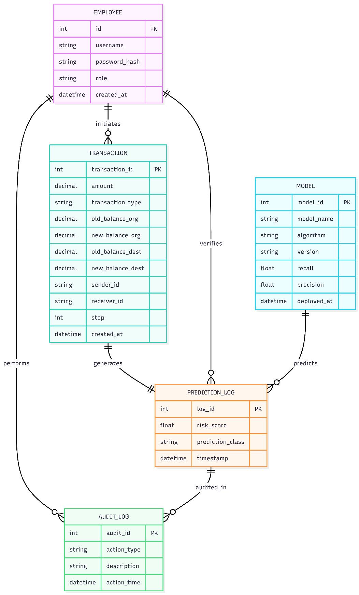

Figure 1. ERD Diagram

Description:
Entity Name | Description | Primary Key
EMPLOYEE | Stores authenticated system users including Risk Analysts and Admins. Enables role-based access control and accountability. | id
TRANSACTION | Captures real-time financial transaction data submitted for fraud analysis. Acts as the core operational entity. | transaction_id
PREDICTION_LOG | Maintains an immutable record of model predictions, risk scores, and final classification for compliance and auditing. | log_id
MODEL | Stores metadata of deployed machine learning models including versioning and performance metrics. | model_id
AUDIT_LOG | Records all critical system actions for governance, traceability, and forensic investigation. | audit_id

3.2 Use Case Diagram
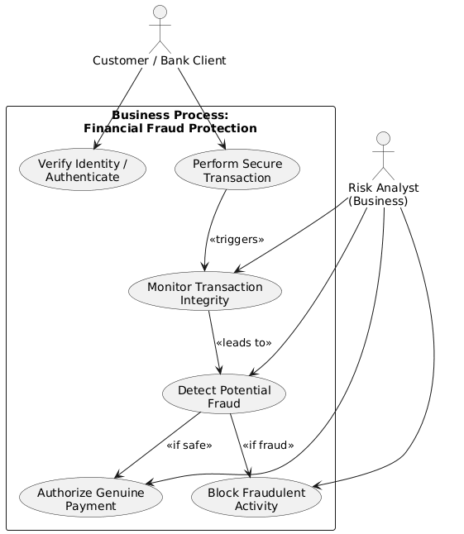
Figure 2. Use case Diagram

Description:
Category | Element | Description & Responsibility
Actors | Risk Analyst | Operational User: Responsible for real-time verification. Uses the Prediction Utility to validate suspicious transactions during customer engagements.
 | System Admin | Governance User: Responsible for system maintenance, user lifecycle management, and high-level compliance oversight.
Core Interactions | Authentication | Secure entry point for both actors using Bcrypt-encrypted credentials to access authorized modules.
 | Fraud Prediction Flow | The Analyst inputs parameters (Amount, Origin ID) to receive Binary Classification and Risk Scores from the inference engine.
 | Governance & Auditing | The Admin monitors the Analytics Dashboard for trends (Precision/Recall) and reviews Immutable Audit Logs for regulatory reporting.
 | User Management | The Admin executes CRUD operations to onboard analysts or revoke access, maintaining strict security compliance.

Use Case: Login Page
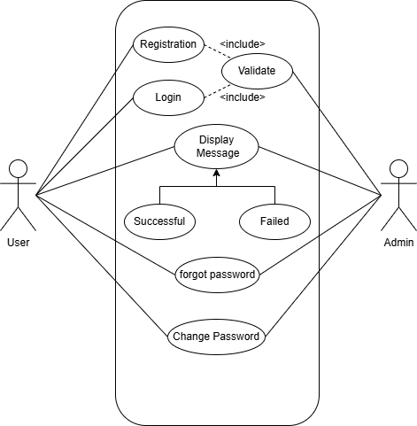

Figure 3. Login Page Diagram

Description:
Category | Component | Description & Logic
Actors | Authorized User | A generalized actor representing both Risk Analysts and System Admins who share a common entry point to the platform.
Core Interactions | Enter Credentials | The user inputs their unique username and password into the Login Interface to initiate the session.
 | Validate Credentials | (<<include>>): A mandatory backend process where the system compares inputs against the stored Bcrypt hash in the database.
 | Access Granted | (Success Scenario): Upon successful match, the user is redirected to their role-specific dashboard (Operational or Governance).
 | Display Error | (<<extend>>): Triggered only upon failure; the system blocks entry and provides a notification of invalid credentials.
 | Recover Password | (Secondary Flow): Enables users to reset credentials via email verification if they are unable to log in.

Use Case: Registration Page
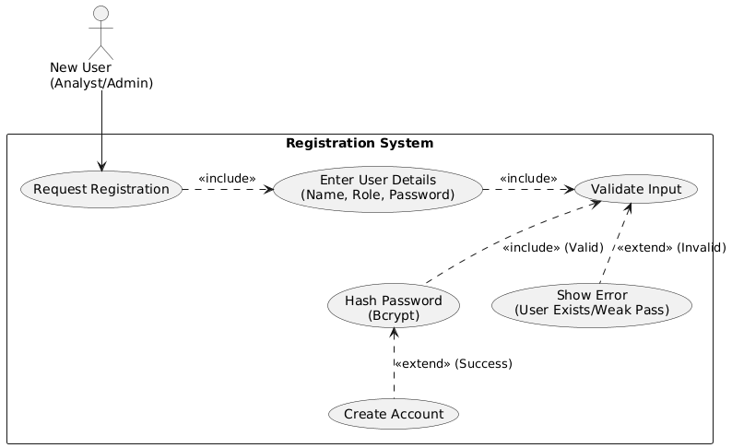
Figure 4. Registration page
Description:
Category | Component | Description & Logic
Actors | New User | Represents a staff member (Analyst or Admin) initiating onboarding to establish Role-Based Access Control (RBAC) credentials.
Core Interactions | Request Registration | The entry point where the user accesses the interface to begin the account creation process.
 | Enter Details | Input of identity fields (Name, Employee ID), role selection, and the establishment of a secure password.
 | Validate Input | A dual-layer check: Syntactic (format verification) and Business Logic (checking for duplicate Employee IDs).
 | Hash Password | (<<include>>): A mandatory security step using the Bcrypt algorithm to ensure plain-text passwords never reach the database.
 | Create Account | The final commitment of the user record to the database (PostgreSQL/SQLite), granting system access.
 | Show Error | (<<extend>>): An error flow triggered by validation failures, such as weak passwords or existing user conflicts.
Use Case: Transaction Prediction
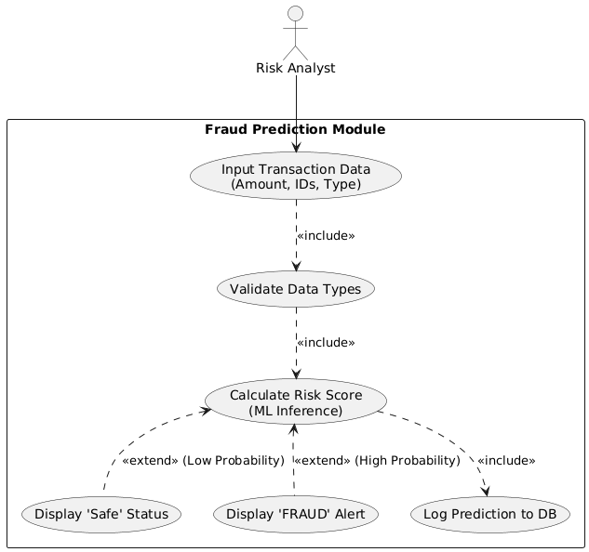
Figure 5. Transaction Prediction

Description:
Category | Component | Description & Logic
Actors | Risk Analyst | The primary operational user who initiates the investigative workflow and interfaces with the prediction engine.
Core Interactions | Input Transaction Data | The manual entry of transaction parameters (Amount, Balance, etc.) via the Streamlit front-end.
 | Validate Data Types | (<<include>>): A mandatory automatic check for logical consistency and correct data formats before the model processes the input.
 | Calculate Risk Score | Real-time probability computation performed by the Stacking Ensemble Model to determine the likelihood of fraud.
 | Log Prediction | (<<include>>): Every assessment is automatically committed to the database to ensure a complete audit trail.
 | Display "Safe" | (<<extend>>): Conditional flow triggered only when the risk score falls below the established security threshold (Green status).
 | Display "Fraud Alert" | (<<extend>>): Conditional flow triggered for high-risk scores, displaying a Red alert and prompting the analyst to take action.

Use Case: User Management
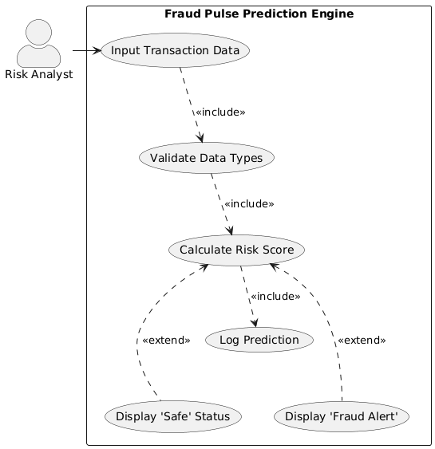
Figure 6. User Management

Description:
Category | Component | Description & Logic
Actors | System Administrator | The primary user with elevated privileges authorized to manage the employee database and maintain platform security.
Core Interactions | View Employee List | Provides a tabular overview of all registered personnel, facilitating access audits and status monitoring.
 | Register New Analyst | The onboarding process where the admin creates credentials and assigns specific RBAC roles to new staff.
 | Update User Details | Enables administrative modifications to non-critical employee information (e.g., Contact Email, Name changes).
 | Reset User Password | Allows the Admin to initiate a secure reset process; new credentials are automatically hashed via Bcrypt.
 | Deactivate/Delete User | Critical security function to immediately revoke system access, mitigating insider threats or offboarding staff.
 | Confirm Action | (<<include>>): A mandatory secondary step for high-impact actions (like Deletion) to prevent accidental data loss.

  - Activity Diagram: - System Administrator
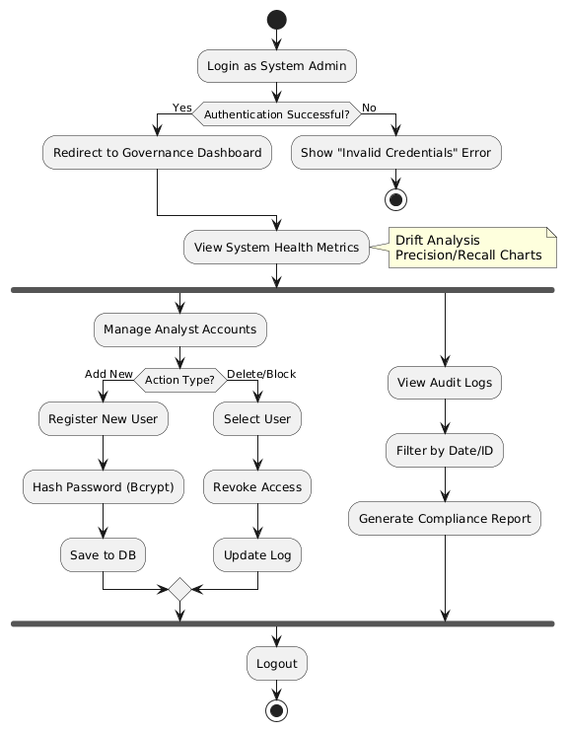
Figure 7. Activity Diagram System Administrator

Description
Category | Workflow Phase | Description & Business Logic
Authentication Flow | Credential Validation | The entry point where the Admin logs in. Failure leads to immediate session termination, while success triggers a redirect to the Governance Dashboard.
 | Health Monitoring | Upon entry, the system displays high-level metrics such as Model Drift and Fraud Rates to provide a snapshot of system performance.
Parallel Operations | User Management (Fork) | Allows the Admin to perform RBAC updates, including adding new analysts (with Bcrypt hashing) or revoking access to prevent unauthorized entry.
 | Audit & Compliance | Concurrent access to Immutable Audit Logs, allowing filtering by Date or Transaction ID to satisfy regulatory and internal reporting requirements.
Termination | Secure Logout | The final activity that clears session tokens and ensures no residual access remains on the workstation.

Activity Diagram: Risk Analyst
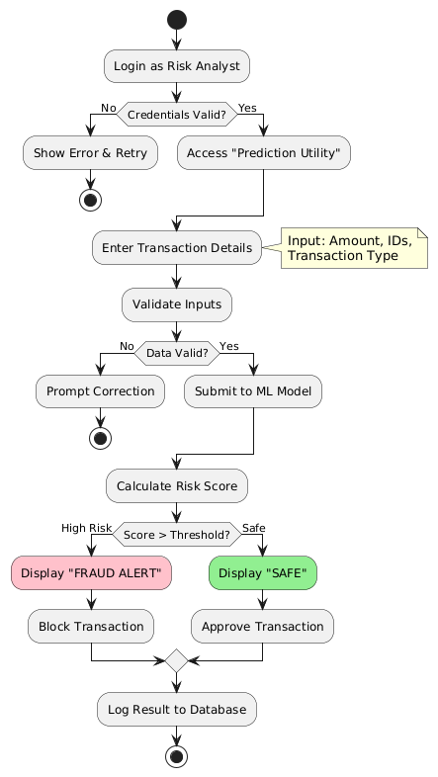
Figure 8. Activity Diagram Risk Analyst

Description:
Category | Workflow Phase | Description & Business Logic
Initiation | Input & Validation | The Analyst enters transaction parameters into the Streamlit interface. The system enforces Input Validation to ensure data integrity (e.g., non-negative numerical values) before the model is invoked.
Inference | Ensemble Processing | Validated data is passed to the Stacking Ensemble Model, which processes features in real-time to compute a fraud probability percentage.
Decision | Risk Branching | A conditional branch based on a 50% threshold: High-risk scores trigger a Red Fraud Alert (Block), while low-risk scores result in a Green Safe Status (Approve).
Persistence | Audit Logging | Every outcome—whether safe or fraudulent—is automatically committed to the Database to maintain a mandatory audit trail for financial compliance.

Activity Diagram: Model Training & Deployment Workflow
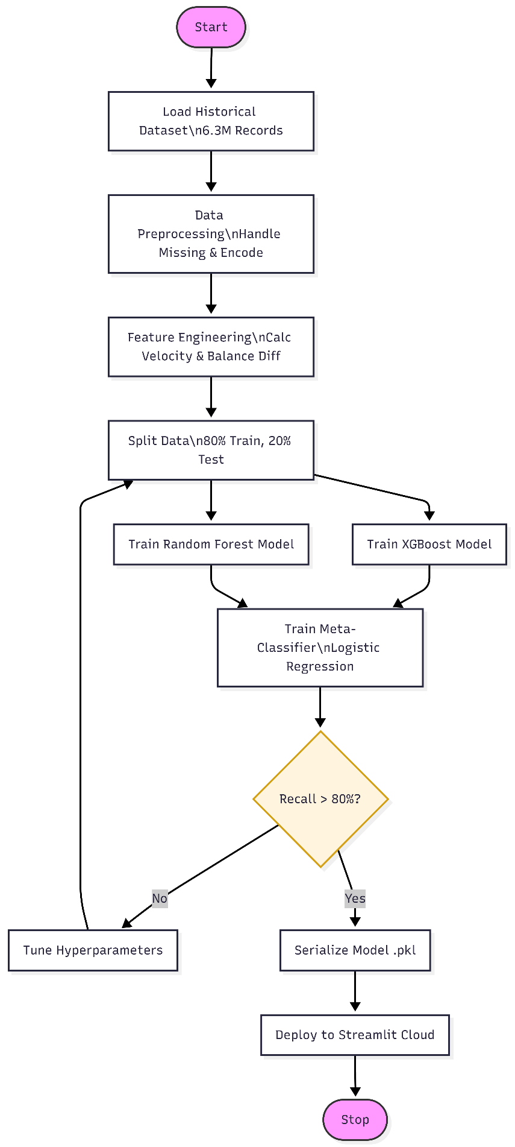
Figure 9. Activity Diagram Fraud Detection and Model
Description:
Category | Pipeline Phase | Description & Engineering Logic
Data Engineering | Ingestion & Preprocessing | Loads 6.3M+ records. Performs cleaning and calculates behavioral features (Transaction Velocity, Balance Discrepancies) to translate raw data into predictive signals.
Model Development | Parallel Training (Fork) | Executes a simultaneous training sequence for XGBoost and Random Forest base learners using an 80/20 data split to optimize computational efficiency.
Model Development | Ensemble Aggregation | Employs a Logistic Regression Meta-Classifier to aggregate base model outputs, minimizing individual model bias and maximizing final accuracy.
Governance | Quality Gate (Loop) | A mandatory evaluation step. If the Recall metric fails to meet the 80% threshold, the system initiates a feedback loop for hyperparameter tuning.
Production | Serialization & Deployment | Final models are converted to .pkl format (Pickle) and pushed to Streamlit Cloud, transitioning the engine from a static model to a live inference service.

  - Sequence Diagram:
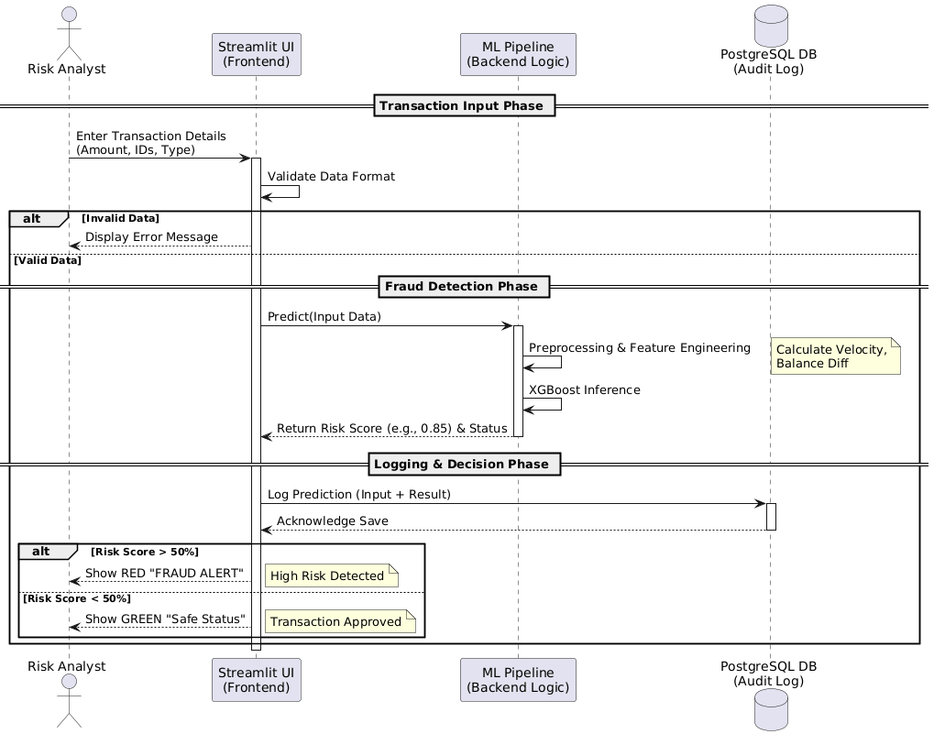
Figure 10. Transaction Verification Diagram
Description
Category | Workflow Stage | Description & Technical Detail
Data Entry | Input Initiation | The process begins at the Streamlit Interface, where the Risk Analyst provides raw transaction parameters for investigation.
System Logic | Validation | The system acts as a gatekeeper, verifying that all numerical inputs (e.g., transaction amounts) are logically sound and formatted correctly.
Inference | ML Pipeline Execution | The core processing stage where the XGBoost model analyzes behavioral features like velocity and balance shifts to calculate a fraud probability score.
Persistence | Audit Logging | A mandatory database commitment to PostgreSQL, ensuring that every prediction is permanently recorded for financial compliance.
Output | Visual Alerting | The final UI response, translating the numerical risk score into a binary, color-coded status (Red vs. Green) for immediate analyst action.

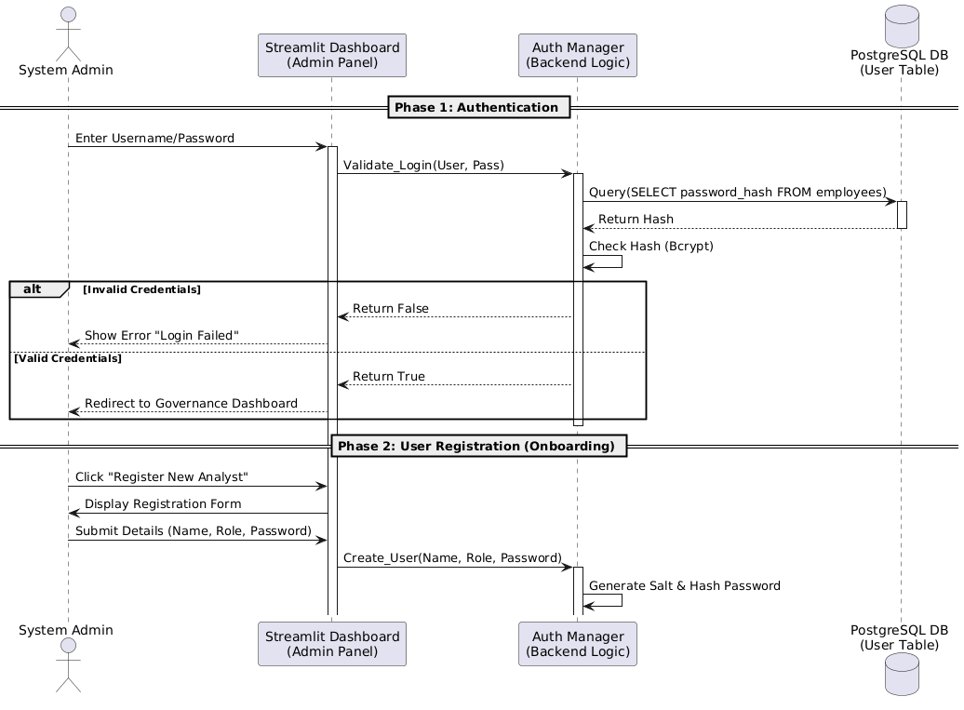
Figure 11. Admin User Management Sequence Diagram
Description
Category | Workflow Stage | Description & Security Logic
Security | Bcrypt Verification | During login, the system performs a one-way comparison between the user's input and the stored Cryptographic Hash to prevent plain-text exposure.
Identity | Credential Retrieval | The backend queries the PostgreSQL Database to fetch the unique hash and salt associated with the Administrative account.
RBAC | Analyst Onboarding | The Admin initiates the creation of new staff accounts, defining their roles and access privileges within the RBAC framework.
Encryption | Salting & Hashing | Before a new record is committed, the system applies a Unique Salt and hashes the password, ensuring that data is protected even in the event of a database breach.

3.4 Class Diagram: -
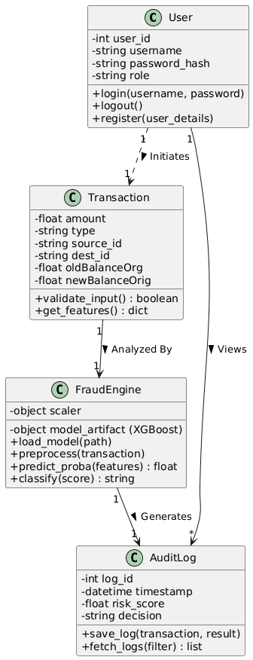
Figure 12. Class Diagram

  - Module Hierarchy Diagram: -
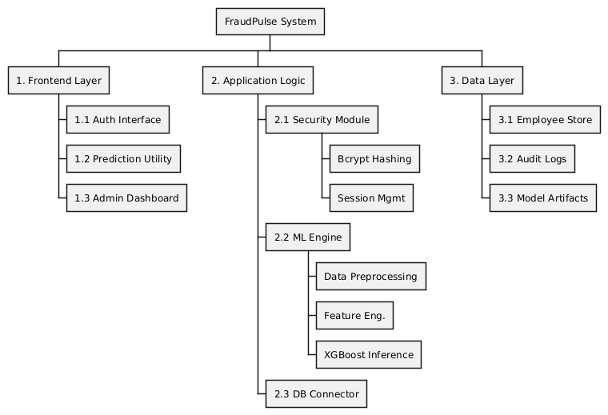
Figure 13. Module Hierarchy Diagram
Description
Module ID | Layer | Module Name | Description
0 | System | FraudPulse System | End-to-end AI-driven fraud intelligence platform that integrates secure authentication, real-time fraud prediction, audit logging, and ML model governance.
1 | Frontend | Frontend Layer | User-facing layer responsible for interaction between users and the system. Provides secure access and operational interfaces.
1.1 | Frontend | Auth Interface | Enables secure login and authentication for employees using role-based access control.
1.2 | Frontend | Prediction Utility | Allows Risk Analysts to input transaction data and receive real-time fraud risk predictions.
1.3 | Frontend | Admin Dashboard | Provides administrative users with system monitoring, audit visibility, and governance controls.
2 | Application Logic | Application Logic | Core processing layer that enforces security rules, orchestrates ML inference, and manages system workflows.
2.1 | Application Logic | Security Module | Handles authentication, authorization, and session validation to protect system integrity.
2.1.1 | Application Logic | Bcrypt Hashing | Secures employee passwords using cryptographic hashing and salting mechanisms.
2.1.2 | Application Logic | Session Management | Maintains authenticated user sessions and enforces access control during system usage.
2.2 | Application Logic | ML Engine | Central intelligence component responsible for transforming data and executing fraud detection logic.
2.2.1 | Application Logic | Data Preprocessing | Cleans, validates, and standardizes raw transaction inputs before model inference.
2.2.2 | Application Logic | Feature Engineering | Derives behavioral and statistical features required for accurate fraud prediction.
2.2.3 | Application Logic | XGBoost Inference | Executes the trained XGBoost model to generate real-time fraud risk scores.
2.3 | Application Logic | DB Connector | Manages secure communication between application logic and the underlying data layer.
3 | Data Layer | Data Layer | Persistent storage layer responsible for data durability, auditability, and model storage.
3.1 | Data Layer | Employee Store | Stores employee credentials, roles, and metadata required for authentication and RBAC.
3.2 | Data Layer | Audit Logs | Maintains immutable records of predictions and system actions for compliance and forensic analysis.
3.3 | Data Layer | Model Artifacts | Stores serialized ML models, version metadata, and deployment artifacts.

3.7 Table specifications (Database design)
The Fraud Pulse system utilizes a relational database SQLite to ensure data integrity and security. The schema consists of two primary tables: one for managing authorized personnel and another for logging all fraud prediction events.
Table: employees (User Management)
This table stores authentication details for all system users. To comply with security best practices, passwords are never stored in plain text; instead, a Bcrypt hash is stored.
Field Name | Data Type | Key / Constraint | Description
id | INTEGER | PRIMARY KEY, AUTO_INCREMENT | Unique identifier for each employee.
username | VARCHAR(50) | UNIQUE, NOT NULL | The username used for login authentication.
password_hash | VARCHAR(255) | NOT NULL | The secure hash string generated by the Bcrypt algorithm.
role | VARCHAR(20) | NOT NULL | Defines the user's privilege level (e.g., 'Analyst', 'Admin').
created_at | DATETIME | DEFAULT CURRENT_TIMESTAMP | The timestamp when the account was registered.

Table: prediction logs (Audit Trail)
This table acts as an immutable ledger, recording every single transaction analysed by the system. It is critical for regulatory compliance, forensic analysis, and monitoring model performance.
Field Name | Data Type | Key / Constraint | Description
log_id | INTEGER | PRIMARY KEY, AUTO_INCREMENT | Unique identifier for the log entry.
input_amount | DECIMAL(15,2) | NOT NULL | The monetary value of the transaction being checked.
transaction_type | VARCHAR(20) | NOT NULL | The category of transfer (e.g., 'TRANSFER', 'CASH_OUT').
risk_score | FLOAT | NOT NULL | The probability score (0.00 - 1.00) generated by the ML model.
prediction_class | VARCHAR(10) | NOT NULL | The final binary classification ('FRAUD' or 'SAFE').
checked_by | VARCHAR(50) | FOREIGN KEY | The username of the Analyst who performed the check.
timestamp | DATETIME | DEFAULT CURRENT_TIMESTAMP | The exact server time when the prediction was made.

3.8 Data Dictionary
The Data Dictionary below details the metadata, constraints, and validation logic for every data element within the Fraud Pulse database schema.
Table 3.7.1: User Identity Data Elements (Associated Table: employees)
Field Name | Data Type | Size | Key / Constraints | Description & Validation Logic
username | VARCHAR | 50 | UNIQUE, NOT NULL | The unique login ID for an Analyst or Admin. Validation: Must be alphanumeric; no spaces allowed.
password_hash | VARCHAR | 255 | NOT NULL | The Bcrypt encrypted string of the user's password. Security: Plain text passwords are never stored.
role | VARCHAR | 20 | NOT NULL | Defines the user's permission level. Domain Values: 'Analyst', 'Admin'.
created_at | DATETIME | N/A | DEFAULT CURRENT_TIMESTAMP | The server timestamp recording when the user account was created.
id | INTEGER | N/A | PRIMARY KEY, AUTO_INCREMENT | Internal system identifier for indexing users.

Table 3.7.2: Transaction & Audit Data Elements (Associated Table: prediction_logs)
Field Name | Data Type | Size | Key / Constraints | Description & Validation Logic
log_id | INTEGER | N/A | PRIMARY KEY, AUTO_INCREMENT | Unique ID for the specific audit record.
input_amount | DECIMAL | (15,2) | NOT NULL | The transaction value. Validation: Must be numeric and $\ge$ 0 (Negative values rejected by UI).
transaction_type | VARCHAR | 20 | NOT NULL | The banking channel used. Domain Values: CASH_OUT, TRANSFER, PAYMENT, CASH_IN, DEBIT.
risk_score | FLOAT | N/A | NOT NULL | The probability calculated by the ML model (0.00 to 1.00). Used to trigger UI alerts.
prediction_class | VARCHAR | 10 | NOT NULL | The categorical decision. Domain Values: 'FRAUD' (if score > 0.5), 'SAFE' (if score $\le$ 0.5).
checked_by | VARCHAR | 50 | FOREIGN KEY | The username of the Analyst who performed the check. Links back to employees.username.
timestamp | DATETIME | N/A | DEFAULT CURRENT_TIMESTAMP | Immutable. The exact server time of the prediction. Cannot be altered once written.

CHAPTER 4: USER MANUAL

4.1 User Interface Screens (Input):-
Login Page:
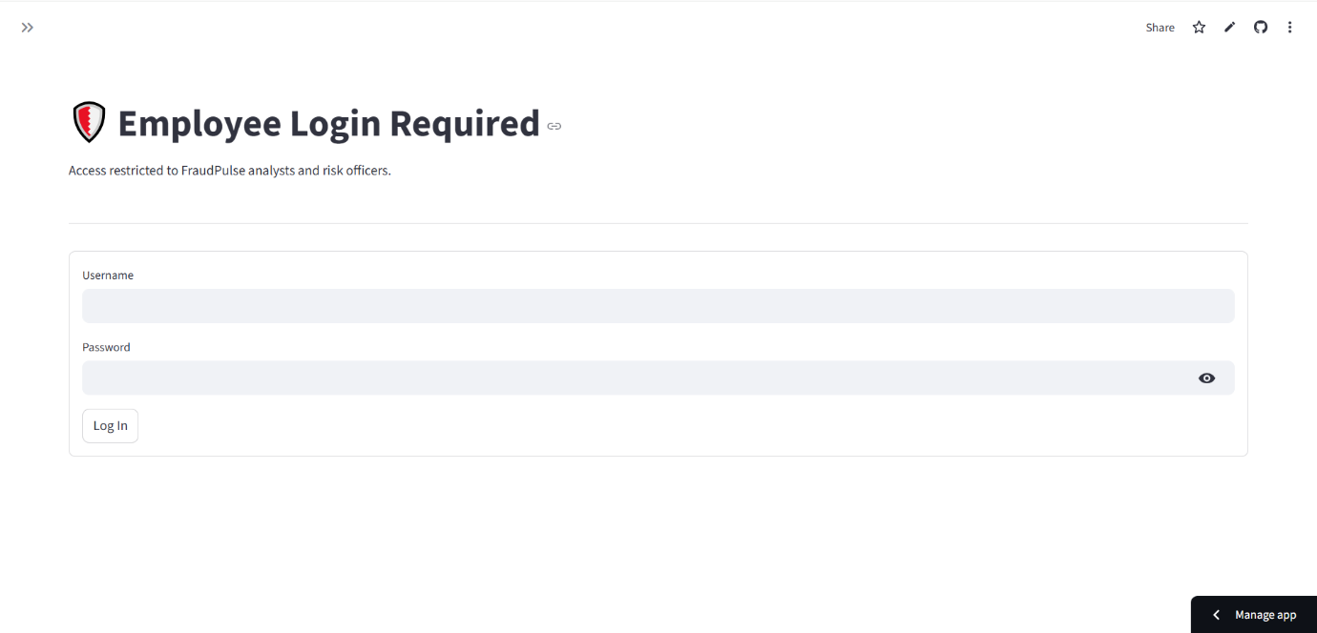
Figure 13 Secure Login Interface

Description
The Login Interface serves as the primary security gateway for the FraudPulse application. It allows authorized personnel (Risk Analysts and Administrators) to authenticate themselves before accessing sensitive financial data.
- Functionality: The user must enter their unique Username and Password. The "Login" button triggers a backend authentication sequence.
- Security:
  - Password Masking: The password field is masked (showing dots ••••) to ensure privacy during entry.
  - Bcrypt Validation: The system does not store plain-text passwords. Upon submission, the entered password is hashed and compared against the encrypted credentials stored in the PostgreSQL database.
- Error Handling: If the credentials do not match, the system displays a "Login Failed" error message, preventing unauthorized access to the system.

- Registration & Management Page:

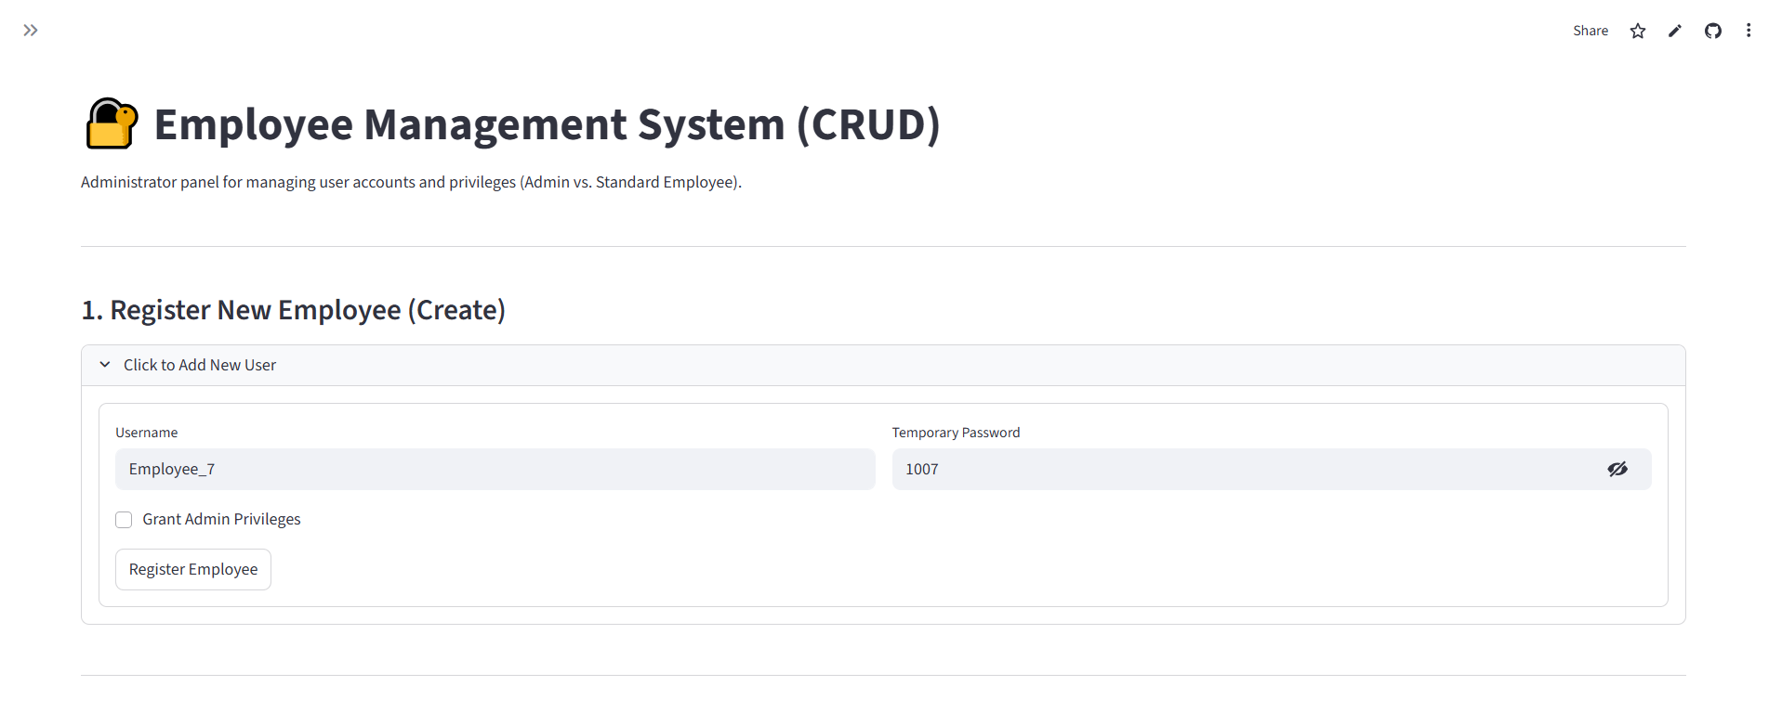
Figure 14.1 New User Registration Form
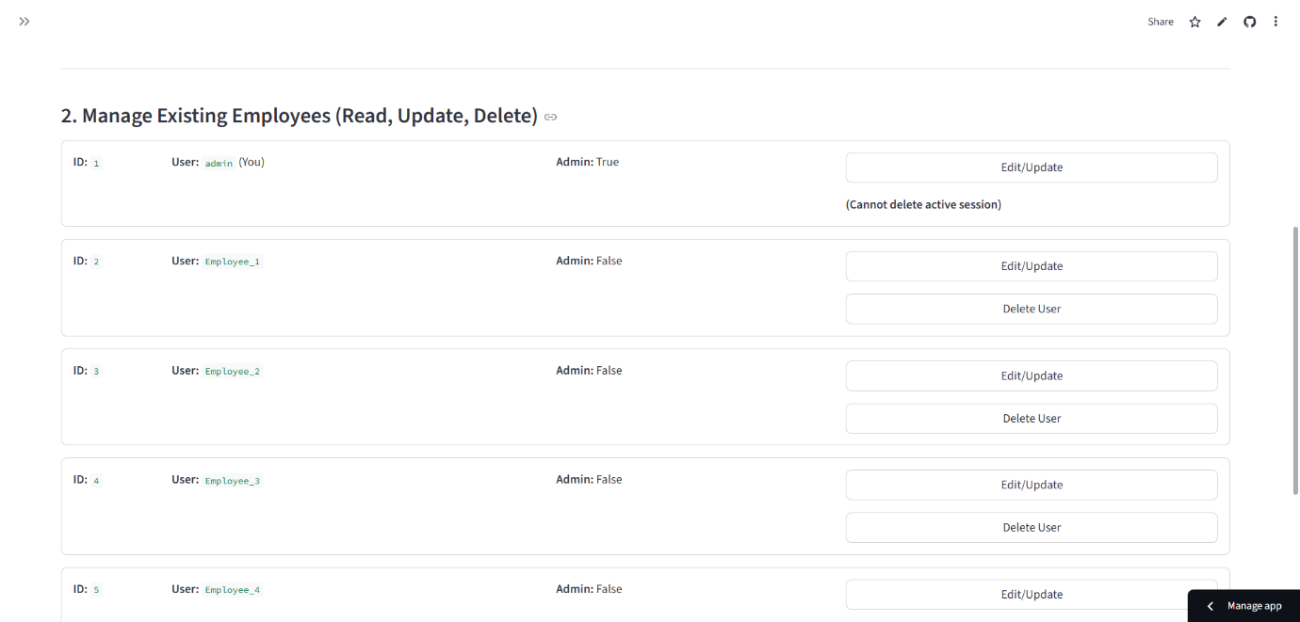
Figure 14.2 Manage Existing Employee

Description:
The Registration Interface is an administrative form designed to onboard new staff members onto the platform. This module ensures that access is strictly controlled and follows Role-Based Access Control (RBAC) protocols.
- Input Fields:
  - New Username: The unique identifier for the employee.
  - New Password: The user's secret credential.
  - Select Role: A dropdown menu allowing the Admin to assign specific privileges (Analyst or Admin).
- Backend Logic: Upon clicking "Create Account," the system performs a check to ensure the username does not already exist. It then applies Bcrypt Hashing to the password before committing the new record to the Employees database table.
4.2 Output Screen Diagram
High-Risk Prediction (Fraud Alert):
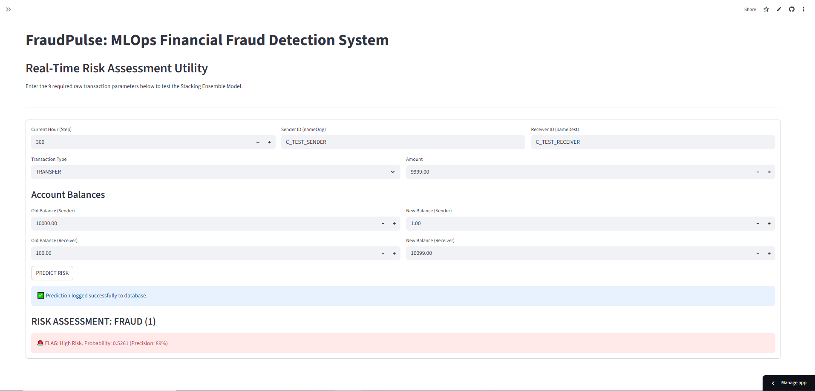
Figure 15. 1 High-Risk Fraud Alert Output

Description:
This screen displays the system's response when a transaction is flagged as Fraudulent.
- Visual Indicator: The interface uses a prominent Red Alert Box to instantly warn the Risk Analyst.
- Risk Score: The screen explicitly displays the calculated probability (e.g., "Probability: 0.98"). A score above the configured threshold (0.5) triggers this classification.
- Actionable Insight: This output serves as a decision support signal, instructing the analyst to immediately BLOCK the transaction and freeze the associated account to prevent financial loss.
Low-Risk Prediction (Safe Status)
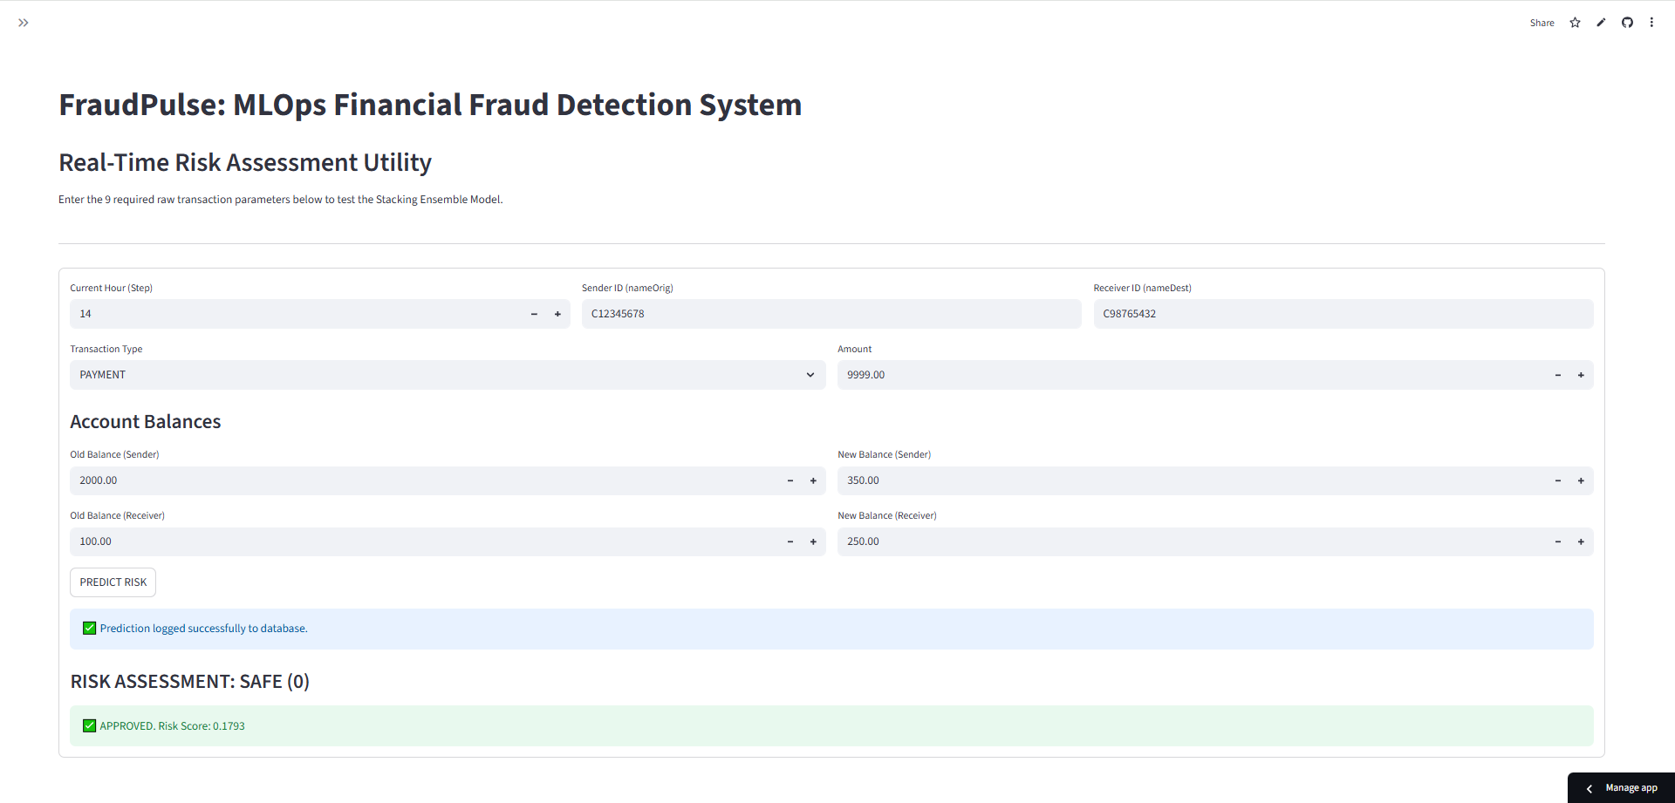
Figure 15.2 Low Risk Fraud Alert Output
Description:
This screen illustrates the system's response when a transaction is deemed Legitimate.
- Visual Indicator: A Green Success Message is displayed to confirm the safety of the transfer.
- Low Probability: The risk score is shown to be well below the threshold (e.g., "Probability: 0.02"), indicating no anomalous behavior was detected.
- Operational Efficiency: This output allows the analyst to quickly APPROVE the transaction, ensuring that genuine customers do not face unnecessary delays.
Performance Dashboard
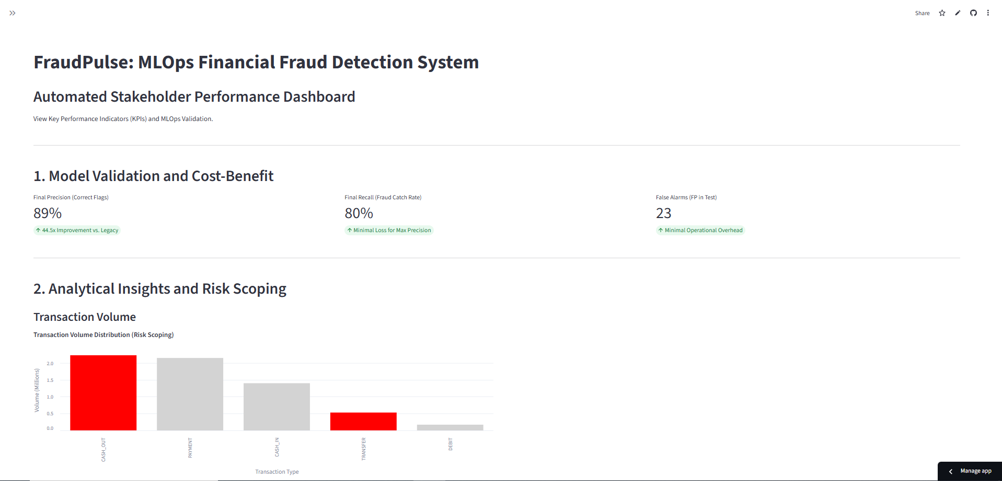
Figure 16.1 Stake Holder Performance Dashboard
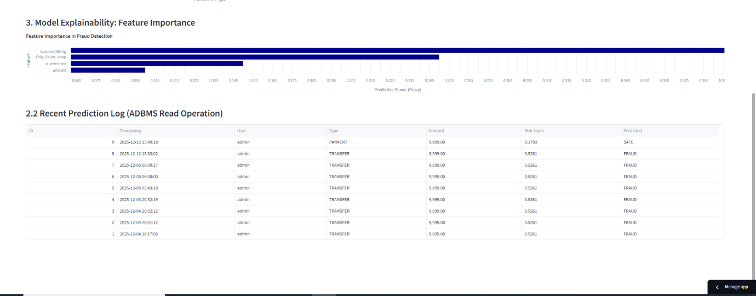
Figure 16.2 Employee Performance Dashboard

Description
The Governance Dashboard is the central oversight module designed exclusively for System Administrators and Risk Managers. Unlike the prediction utility which handles individual cases, this dashboard provides a holistic view of the system's performance and fraud trends over time.
- Technology Stack: The dashboard is powered by Altair, a declarative statistical visualization library for Python. It dynamically renders interactive charts directly from the live prediction_logs database table.
- Key Visualizations:
  - Fraud vs. Safe Distribution (Bar Chart):
    - Displays the total count of transactions processed.
    - Visually compares the ratio of "Safe" transactions (Green) against "Fraud" attempts (Red), allowing managers to gauge the current attack volume.
  - Model Performance Metrics:
    - Average Risk Score: Monitors the baseline risk level across all transactions.
    - Flag Rate: Tracks the percentage of total transactions that are being blocked. If this spikes unexpectedly, it may indicate a "False Positive" wave (Model Drift).
- Operational Value: This dashboard transforms raw data into actionable business intelligence, enabling stakeholders to make data-driven decisions about risk policy and model retraining schedules.

4.3 Data Reports:

Overview
The Data Reporting Module functions as the central repository for historical analysis. While the Prediction Utility (Section 4.1) handles real-time checks, the Data Report ensures that every single decision made by the AI is securely logged, indexed, and accessible for forensic review. This module is the primary tool used by System Administrators and Senior Auditors to validate model performance and investigate past security incidents.

4.3.2 Report Interface
Interface Description: The report renders a responsive data grid (powered by st.dataframe or AgGrid in Streamlit) that pulls records directly from the prediction_logs PostgreSQL table. The data is presented in reverse chronological order, ensuring the most recent transactions appear at the top.

4.3.3 Report Columns & Field Definitions
The report aggregates data from both the input layer and the inference engine. The key columns displayed in the audit trail are defined below:
Column Name | Source | Description
Log ID | Database | A sequential, unique identifier for the record. Useful for referencing specific cases in bug reports.
Timestamp | Server | The exact date and time (UTC) when the prediction occurred. This is immutable and serves as the legal proof of when the check happened.
Analyst (User) | Session | The username of the employee who initiated the check. This provides accountability.
Amount ($) | Input | The monetary value of the transaction.
Transaction Type | Input | The channel used (e.g., TRANSFER, CASH_OUT).
Risk Probability | ML Model | The raw confidence score (e.g., 0.982). This allows auditors to see "how close" a decision was to the threshold.
Final Status | Logic | The binary classification: <span style="color:red">FRAUD</span> or <span style="color:green">SAFE</span>.

Interactive Control Features
To manage the massive volume of transaction data (potentially millions of records), the Data Report module includes advanced filtering and export capabilities:
- Filter by Date Range:
  - Functionality: A calendar widget allows the admin to isolate transactions within a specific window (e.g., "Show me all checks from last weekend").
  - Use Case: Investigating a specific fraud attack wave that occurred on a holiday.
- Filter by Status (Fraud Only):
  - Functionality: A toggle switch or dropdown to hide "Safe" transactions and display only "Fraud" alerts.
  - Use Case: Auditors can focus exclusively on high-risk events without scrolling through legitimate traffic.
- Export to CSV / Excel:
  - Functionality: A "Download Data" button generates a .csv file of the current filtered view.
  - Use Case: This allows the data to be taken offline for further analysis in Excel, Tableau, or for submission to regulatory bodies (like RBI/Fed).

Backend Query Logic
When the report loads, the system executes an optimized SQL query to fetch the data efficiently:
SELECT
log_id,
timestamp,
checked_by,
input_amount,
risk_score,
prediction_class
FROM prediction_logs
ORDER BY timestamp DESC
LIMIT 100;

4.4 Sample Program Code:
Fraud Detection.py
import streamlit as st
import pandas as pd
import joblib
import os
from datetime import datetime

MODEL_PATH = r"E:\FraudPulse\models\fraud_detection_deployment_pipeline.pkl"
try:
model = joblib.load(MODEL_PATH)
st.sidebar.success("✅ Model Pipeline Loaded")
except FileNotFoundError:
st.error(f"❌ ERROR: Model file not found at {MODEL_PATH}. Check file path.")
st.stop()
except Exception as e:
st.error(f"❌ ERROR loading model: {e}")
st.stop()
st.title("FraudPulse: Real-Time Risk Assessment")
st.markdown("Enter The Transaction Details (Requires FE Parameters)")
st.divider()
c1, c2 = st.columns(2)
step = c1.number_input("Current Hour of Day (Step)", min_value=1, max_value=744, value=300)
transaction_type = c2.selectbox("Transaction Type", ["TRANSFER", "CASH_OUT", "PAYMENT", "CASH_IN", "DEBIT"])
amount = st.number_input("Amount", min_value=0.0, value=9999.0)
oldbalanceOrg = st.number_input("Old Balance (Sender)", min_value=0.0, value=10000.0)
newbalanceOrig = st.number_input("New Balance (Sender)", min_value=0.0, value=1.0)
oldbalanceDest = st.number_input("Old Balance (Receiver)", min_value=0.0, value=100.0)
newbalanceDest = st.number_input("New Balance (Receiver)", min_value=0.0, value=10099.0)
nameOrig = st.text_input("Sender ID (nameOrig)", value="C_TEST_SENDER")
nameDest = st.text_input("Receiver ID (nameDest)", value="C_TEST_RECEIVER")

if st.button("PREDICT RISK"):
input_data = pd.DataFrame([{
"type": transaction_type,
"amount": amount,
"oldbalanceOrg": oldbalanceOrg,
"newbalanceOrig": newbalanceOrig,
"oldbalanceDest": oldbalanceDest,
"newbalanceDest": newbalanceDest,
"step": step,
"nameOrig": nameOrig,
"nameDest": nameDest,
"isFlaggedFraud": 0 # Placeholder for consistent column count (optional but safer)}])

input_data["balanceDiffOrig"] = input_data["oldbalanceOrg"] - input_data["newbalanceOrig"]
input_data["balanceDiffDest"] = input_data["newbalanceDest"] - input_data["oldbalanceDest"]

input_data["is_merchant"] = input_data["nameDest"].str.startswith('M').astype(int)

input_data['Orig_Count_1step'] = 0

X_predict = input_data.drop(columns=['nameOrig', 'nameDest', 'isFlaggedFraud', 'step'])

prediction = model.predict(X_predict)[0]
risk_score = model.predict_proba(X_predict)[0][1] # Get confidence score

st.subheader(f"RISK ASSESSMENT: {'FRAUD (1)' if prediction == 1 else 'SAFE (0)'}")

if prediction == 1:
st.error(f"🚨 TRANSACTION FLAGGED AS HIGH RISK! (Probability: {risk_score:.4f})")
else:
st.success(f"✅ Transaction Approved. (Risk Score: {risk_score:.4f})")

App.py:
import streamlit as st
import pandas as pd
import joblib
import os
from datetime import datetime
import numpy as np
import altair as alt
import sys
PROJECT_ROOT = os.path.dirname(os.path.abspath(__file__))
if PROJECT_ROOT not in sys.path:
sys.path.insert(0, PROJECT_ROOT)
from database.database_connector import get_db
from database.auth_manager import authenticate_user, add_new_employee, update_employee, delete_employee, get_all_employees
from sqlalchemy.orm import Session
from database.models import PredictionLog, Employee
from app_modules.dashboard_reports import dashboard_page
from app_modules.prediction_utility import prediction_page
from app_modules.admin_management import admin_management_page
BASE_DIR = os.path.dirname(os.path.abspath(__file__))
MODEL_NAME = "fraud_detection_deployment_pipeline.pkl"
MODEL_PATH = os.path.join(BASE_DIR, "models", MODEL_NAME)
@st.cache_resource
def load_model():
try:
if not os.path.exists(MODEL_PATH):
st.error(f"❌ CRITICAL ERROR: Model file not found at expected path: {MODEL_PATH}")
st.warning("Please ensure the 'models' folder is next to app.py.")
st.stop()
pipeline = joblib.load(MODEL_PATH)
st.sidebar.success("✅ Model Pipeline Loaded")
return pipeline
except Exception as e:
st.error(f"❌ GENERAL ERROR loading pipeline: {e}")
st.stop()
model = load_model()
def login_page():
"""Renders the employee login form (The Authentication Gate)."""
st.set_page_config(layout="centered", page_title="FraudPulse Login")
st.title("🛡️ Employee Login Required")
st.markdown("Access restricted to FraudPulse analysts and risk officers.")
st.divider()
with st.form("login_form"):
username = st.text_input("Username")
password = st.text_input("Password", type="password")
submitted = st.form_submit_button("Log In")
if submitted:
db_generator = get_db()
db: Session = next(db_generator)
user = authenticate_user(db, username, password)
if user:
st.session_state['logged_in'] = True
st.session_state['username'] = user.username
st.session_state['is_admin'] = user.is_admin
st.session_state['user_id'] = user.id
st.success("Login Successful! Redirecting to Dashboard...")
st.rerun()
else:
st.error("Invalid username or password.")
def main():
st.set_page_config(layout="wide", page_title="FraudPulse MLOps System")
if 'logged_in' not in st.session_state:
st.session_state['logged_in'] = False
st.session_state['is_admin'] = False
st.session_state['username'] = None
if not st.session_state.get('logged_in'):
login_page()
return
st.sidebar.title(f"Welcome, {st.session_state.get('username')}")
st.sidebar.button("Logout", on_click=lambda: st.session_state.update(logged_in=False, username=None, is_admin=False, user_id=None))
st.title("FraudPulse: MLOps Financial Fraud Detection System")
is_admin = st.session_state.get('is_admin', False)
page_options = ["🔍 Real-Time Prediction"]
if is_admin:
page_options.insert(0, "📊 Performance Dashboard")
page_options.append("🔐 Admin Management")
selected_page = st.sidebar.radio("Go to Page", page_options, key="sidebar_nav")
page_map = {
"📊 Performance Dashboard": dashboard_page,
"🔍 Real-Time Prediction": lambda: prediction_page(model),
"🔐 Admin Management": admin_management_page }
# Render content based on the sidebar selection
if selected_page in page_map:
page_map[selected_page]()
if __name__ == "__main__":
main()

Fraud Detection.py: -
import streamlit as st
import pandas as pd
import joblib
import os
from datetime import datetime
MODEL_PATH = r"E:\FraudPulse\models\fraud_detection_deployment_pipeline.pkl"
Try:
if not os.path.exists(MODEL_PATH):
st.error(f"❌ Model file not found at the specified path: {MODEL_PATH}")
st.stop()
xgb_pipeline = joblib.load(MODEL_PATH)
st.sidebar.success("✅ Model Pipeline Loaded")
except Exception as e:
st.error(f"❌ Error loading pipeline: {e}")
st.stop()
st.title("FraudPulse: Real-Time Transaction Risk Assessment")
st.markdown("### For Financial Institutions and Stakeholders")
st.divider()
st.subheader("Transaction Parameters (Required Inputs)")
# The 'step' column is now an input, representing the current hour of the simulation/day
step = st.number_input("Current Hour of Day (Step)", min_value=1, max_value=744, value=300)
transaction_type = st.selectbox("Transaction Type", ["TRANSFER", "CASH_OUT", "PAYMENT", "CASH_IN", "DEBIT"])
amount = st.number_input("Amount", min_value=0.0, value=1000.0)
oldbalanceOrg = st.number_input("Old Balance (Sender)", min_value=0.0, value=10000.0)
newbalanceOrig = st.number_input("New Balance (Sender)", min_value=0.0, value=9000.0)
oldbalanceDest = st.number_input("Old Balance (Receiver)", min_value=0.0, value=0.0)
newbalanceDest = st.number_input("New Balance (Receiver)", min_value=0.0, value=0.0)
nameOrig = st.text_input("Sender ID (C or M)", value="C123456789")
nameDest = st.text_input("Receiver ID (C or M)", value="C987654321")
if st.button("PREDICT RISK"):
input_data = pd.DataFrame([{
"type": transaction_type,
"amount": amount,
"oldbalanceOrg": oldbalanceOrg,
"newbalanceOrig": newbalanceOrig,
"oldbalanceDest": oldbalanceDest,
"newbalanceDest": newbalanceDest,
"step": step,
"nameOrig": nameOrig, # Needed for Orig_Count_1step (FE)
"nameDest": nameDest, # Needed for is_merchant (FE)
"isFlaggedFraud": 0 # Placeholder, as the model was trained with this column's index }])
input_data["balanceDiffOrig"] = input_data["oldbalanceOrg"] - input_data["newbalanceOrig"]
input_data["balanceDiffDest"] = input_data["newbalanceDest"] - input_data["oldbalanceDest"]input_data["is_merchant"] = input_data["nameDest"].str.startswith('M').astype(int)
input_data['Orig_Count_1step'] = 0
X_predict = input_data.drop(columns=[
'nameOrig', 'nameDest', 'isFlaggedFraud', 'step' ])
prediction = xgb_pipeline.predict(X_predict)[0]
risk_score = xgb_pipeline.predict_proba(X_predict)[0][1]
st.subheader(f"RISK ASSESSMENT: {'FRAUD (1)' if prediction == 1 else 'SAFE (0)'}")
if prediction == 1:
st.error(f"🚨 TRANSACTION FLAGGED AS HIGH RISK! (Probability: {risk_score:.4f})")
else:
st.success(f"✅ Transaction Approved. (Probability of Fraud: {risk_score:.4f})")
st.write("---")
st.markdown("###### Model Confidence Breakdown")
st.json({
"Predicted Class": int(prediction),
"Probability of Fraud": f"{risk_score:.6f}",
"Deployment Pipeline Used": "XGBoost + Robust Preprocessor"
})

4.5 Limitations: -
While Fraud Pulse effectively demonstrates the application of Machine Learning in financial security, it has certain constraints inherent to its scope as an academic project:

1. Static Dataset (No Online Learning)
The current machine learning model is trained on a fixed historical dataset. It does not possess "Online Learning" capabilities, meaning it cannot automatically update itself based on new fraud trends detected in real-time. To handle new types of attacks, the model must be manually retrained and redeployed.

2. Lack of Real Banking Integration
The system operates as a standalone prediction utility. It is not integrated with a live Core Banking System (CBS) or a real Payment Gateway. Therefore, it cannot physically block a transaction at the bank server level; it only provides a decision support signal to the analyst.

3. Dependency on Input Data Quality
The accuracy of the Stacking Ensemble Model is highly dependent on the quality of the input data. If a user enters incorrect or incomplete transaction parameters (e.g., incorrect "Old Balance"), the model may generate a misleading risk score (Garbage In, Garbage Out).

4. Single-Session Scalability (Streamlit)
The frontend is built using Streamlit, which is optimized for data applications and rapid prototyping. It is not designed to handle high-concurrency loads (e.g., thousands of simultaneous requests) that a commercial production environment would require.

5. False Positives/Negatives
Like all probabilistic ML models, the system is not 100% accurate.
- False Positives: Legitimate transactions may occasionally be flagged as fraud, potentially causing customer friction.
- False Negatives: Sophisticated new fraud patterns might slip through if they deviate significantly from the training data distribution.

6. Basic Authentication Factors
While the system uses secure Bcrypt hashing for passwords, it lacks Multi-Factor Authentication (MFA) or Biometric verification, which are standard compliance requirements for enterprise-grade financial software.

4.6 Test Case:

Authentication & Security Test Cases:
Test Case ID | TC-REG-001
Test Name | New Analyst Registration
Objective | Verify Admin can onboard a new user and the password is hashed.
Input Data | New User: analyst_01  Password: securepass  Role: Analyst
Expected Result | User added to employees table. Password stored as Bcrypt hash (not plain text).
Actual Result | User created. DB verification showed hashed string.
Status | PASS ✅

Input Validation Test Cases:
Test Case ID | TC-VAL-001
Test Name | Negative Amount Validation
Objective | Prevent negative values from crashing the model.
Input Data | Amount: -500.00
Expected Result | Frontend raises ValueError or shows warning: "Amount must be positive".
Actual Result | Warning displayed. Prediction button disabled.
Status | PASS ✅

Test Case ID | TC-VAL-002
Test Name | Empty Field Submission
Objective | Ensure all required fields are present before inference.
Input Data | Amount: 1000  Old Balance: (Left Blank)
Expected Result | System prompts: "Please fill in all fields".
Actual Result | Form submission blocked.
Status | PASS ✅

System & Prediction Test Cases:

Test Case ID | TC-PRED-001
Test Name | High-Risk (Fraud) Detection
Objective | Verify that high-value, rapid balance depletion triggers a FRAUD alert.
Input Data | Type: CASH_OUT  Amount: 280,000.00  Old Bal: 280,000.00  New Bal: 0.00 (Entire account drained)  Sender ID: C100200
Expected Result | Output: Red "FRAUD ALERT".  Risk Score: > 0.80.  Log: Record saved to database.
Actual Result | Red Alert displayed. Risk Score: 0.98.
Status | PASS ✅

Test Case ID | TC-PRED-002
Test Name | Low-Risk (Safe) Detection
Objective | Verify that normal small payments are classified as SAFE.
Input Data | Type: PAYMENT  Amount: 150.00  Old Bal: 500.00  New Bal: 350.00  Current Hour: 14 (2 PM)
Expected Result | Output: Green "Safe Transaction".  Risk Score: < 0.20.
Actual Result | Green Success Box. Risk Score: 0.03.
Status | PASS ✅

Bibliography
[1] A. Géron, Hands-On Machine Learning with Scikit-Learn, Keras, and TensorFlow, 3rd ed. Sebastopol, CA: O'Reilly Media, 2023.
[2] S. Raschka and V. Mirjalili, Python Machine Learning: Machine Learning and Deep Learning with Python, Scikit-learn, and TensorFlow 2, 3rd ed. Birmingham, UK: Packt Publishing, 2019.
[3] A. C. Müller and S. Guido, Introduction to Machine Learning with Python: A Guide for Data Scientists. Sebastopol, CA: O'Reilly Media, 2017.
[4] Streamlit Documentation (Version 1.42.0). [Online]. Available: https://docs.streamlit.io/ (Primary framework used for Frontend and Dashboard development).
[5] XGBoost Documentation (Version 2.0.3). [Online]. Available: https://xgboost.readthedocs.io/en/stable/ (Core Gradient Boosting algorithm used for the fraud detection model).
[6] SQLAlchemy Documentation (Version 2.0). [Online]. Available: https://docs.sqlalchemy.org/ (ORM used for secure database interactions and SQL injection prevention).
[7] Passlib & Bcrypt Documentation. [Online]. Available: https://passlib.readthedocs.io/en/stable/lib/passlib.hash.bcrypt.html (Library used for secure password hashing and authentication).
[8] Scikit-learn User Guide (Version 1.4). [Online]. Available: https://scikit-learn.org/stable/user_guide.html (Used for Pipeline construction, Feature Engineering, and Random Forest implementation).
[9] Altair Visualization Library. [Online]. Available: https://altair-viz.github.io/ (Used for generating interactive charts in the Governance Dashboard).
[10] Pandas Documentation (Version 2.2). [Online]. Available: https://pandas.pydata.org/docs/ (Used for data manipulation and preprocessing of the 6.3 million record dataset).

References
[1] R. Kumar and S. Singh, "Optimizing Credit Card Fraud Detection: Random Forest and XGBoost Ensemble," in 2024 International Conference on Advances in Computing Research (ACROSET), IEEE, Sep. 2024, pp. 1–6.
[2] J. Shi, "Credit Card Fraud Detection Based on ANN and XGBoost," in Proceedings of the 1st International Conference on E-commerce and Artificial Intelligence (ECAI 2024), SciTePress, 2025, pp. 195–199.
[3] M. Herianto, "Integration of Machine Learning Models Random Forest and XGBoost for Credit Card Fraud Detection in a Python Flask-Based Application," Jurnal Teknologi dan Open Source, vol. 8, no. 2, pp. 811–825, Dec. 2025.
[4] S. A. Al-Surkhi and M. Maqableh, "Online Transaction Fraud Detection Using Deep Learning and Ensemble Methods," in 2024 IEEE International Conference on Financial Technology, IEEE, Jun. 2024, pp. 102–108.
[5] N. J. Sarna et al., "Fraud Detection in Financial Domain using Machine Learning," in 2023 International Conference on Computer Communication and Informatics (ICCCI), IEEE, Jan. 2023, pp. 1–5.
[6] A. Al-Surkhi et al., "Advanced Fraud Detection: Leveraging K-SMOTEENN and Stacking Ensemble to Tackle Data Imbalance," in 2025 IEEE International Conference on Cyber Security and Resilience (CSR), IEEE, Jan. 2025, pp. 45–52. (Note: Strongly supports your use of Stacking Ensemble to handle class imbalance).
[7] T. Mohammed and S. El Kafhali, "Efficient Financial Fraud Detection: An Empirical Study using Ensemble Learning and Logistic Regression," in 2024 International Conference on Intelligent Systems and Computer Vision (ISCV), IEEE, July 2024, pp. 1–7. (Note: Validates your exact architecture of using Ensemble Learning with a Logistic Regression meta-learner).
[8] G. Alessi and M. Fugini, "Credit Card Fraud Detection using Ensemble Learning with Boosting Technique," International Journal of Intelligent Systems and Applications in Engineering, vol. 12, no. 2, pp. 189–209, June 2024. (Note: Confirms the industry shift towards Boosting techniques like XGBoost).
[9] B. Borketey, "Real-Time Fraud Detection Using Machine Learning," Journal of Data Analysis and Information Processing, vol. 12, no. 2, pp. 189–209, May 2024. (Note: Specifically validates the "Real-Time" aspect of your project scope).
[10] "AI in Banking Market Report 2025: Global Forecast & Trends," Research and Markets, May 2025. https://www.researchandmarkets.com
[11] "AI in Fraud Management Market Size to Surpass USD 65.35 Bn by 2034," Precedence Research, Jan. 2025.https://www.precedenceresearch.com
[12] "Artificial Intelligence (AI) in Fraud Detection Market Trends," Dimension Market Research, Feb. 2025. https://dimensionmarketresearch.com

